Blue-White FlexFlo Series Model M2 Peristaltic Metering Pump
- METERING PUMP – Shall be a positive displacement, peristaltic type tubing pump with a variable speed DC motor, non-spring-loaded roller assembly located in the pumphead, integral tube failure detection system, and peristaltic pump tubing assembly with attached connection fittings. Flex-Pro M2 model shall be capable of output volumes from 0.01 to 21.23 gallons per hour (.032 – 80.4 lph).
  - There shall be no valves, diaphragms, springs, or dynamic seals in the fluid path. Process fluid shall contact the pump tubing assembly and connection fittings only.
  - Capable of self-priming at the maximum rated pressure of up to 125 PSI (8.6 bar).
  - Capable of running dry without damage.
  - Pump rollers shall be capable of operating in either direction at the maximum rated pump pressure.
  - Pump rollers shall be capable of operating in either direction without output variation.
  - Suction lift shall be 30 feet (9 m) of water.
  - Pump shall be warranted by the manufacturer for a period of five years. Warranty shall include chemical damage to the pump head and roller assembly for a period of two years.

- PUMP HEAD – Shall be a single, unbroken track with a clear removable cover
  - Tube failure detection sensors shall be wholly located in the pumphead. Tube failure detection system shall not trigger with water contact. Float switch type switches alone shall not be used. Process fluid waste ports or leak drains alone shall not be provided as the sole means of protection.
  - Squeeze rollers with encapsulated ball bearings shall be directly coupled to a one-piece thermoplastic rotor. Four Nylon rollers shall be provided; two squeeze rollers for tubing compression shall be located 180 degrees apart and two guide rollers that do not compress the tubing shall be located 180 degrees apart. The roller diameters and occlusion gap shall be factory set to provide the optimum tubing compression; field adjustment shall not be required. Spring-loaded or hinged rollers shall not be used.
  - Rotor assembly shall be installed on a D-shaped, chrome plated motor shaft and removable without tools.
  - For tubing installation and removal, rotor assembly shall be rotated by the motor drive at 6 RPM maximum when the pumphead cover is removed. Hand cranking of the rotor assembly shall not be required.
  - Pump head and tubing compression surface shall be corrosion resistant Valox thermoplastic.
  - The pump head cover shall be clear, annealed acrylic thermoplastic with an integral ball bearing fitted to support the overhung load on the motor shaft. Cover shall include an imbedded magnetic safety interlock which will limit the motor rotation speed to 6 RPM when removed.
  - Cover shall be positively secured to the pump head using four thumb screws. Tools shall not be required to remove the pump head cover.

- PUMP TUBE ASSEMBLY
  - To ensure pump performance and accuracy, only tubing provided by the manufacturer is acceptable.
  - Pump tube shall be assembled to connection fittings of PVDF material.
  - Connection fittings shall be permanently attached to the tubing at the factory. To prevent tubing misalignment and ensure accuracy, fittings shall insert into keyed slots located in the pump head and secured in place by the pump head cover.
  - Connection fittings shall be 1/2” M/NPT. (Engineer to specify)
Alternate:
- Fittings shall accept 1/4” ID x 3/8” OD flexible tubing.
- Fittings shall accept 1/2” ID flexible tubing.
- Fittings shall accept one-way check valve Quick Disconnect Adapters. Wetted components shall be PVDF, Viton (optional EPDM), and Hastelloy C spring.
- Fittings shall accept ¾” tri-clamp adapters.
  - Tube sizes and connections shall be measured in inches.
  - The following tube sizes shall be available:
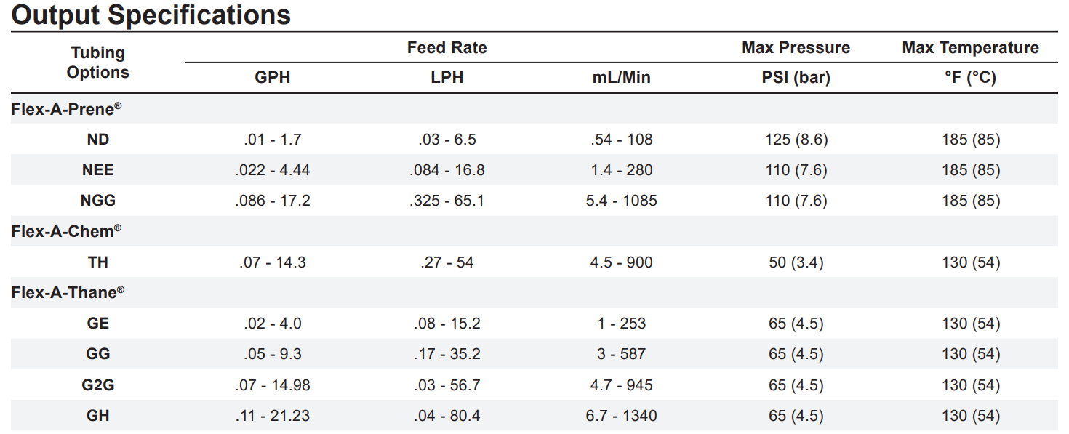

- DRIVE SYSTEM – Shall be factory installed and totally enclosed in a NEMA 4X, (IP66) wash-down enclosure. Capable of operating on 110/130VAC 50/60 Hz, or 208/250VAC 50/60 Hz, single phase supply, user configurable via a selection switch located in the junction box.
  - Motor
    - Reversible, 1/8 HP DC gear motor rated for continuous duty.
    - Motor shall include overload protection.
    - The maximum gear motor RPM shall be 130 RPM.

  - Enclosure
    - Pressure cast aluminum with acidic liquid iron phosphate three-stage clean and coat pretreatment and exterior grade corrosion resistant polyester polyurethane powder coat.
    - Rated NEMA 4X (IP66).
    - Provided with 316SS floor/shelf level mounting brackets and hardware. Optional: provide extended height brackets for mounting pump 4.5 inches above grade level. (Engineer to specify)
    - A wiring compartment shall be provided for connection of input/output signal wires and alarm output loads to un-pluggable type terminal block connectors. Terminal board shall be positively secured to the rear of the pump housing by two polymeric screws and fully enclosed by the wiring compartment cover. The terminal board shall not be disturbed by the removal of the wiring compartment cover. Ribbon cables shall not be used in the wiring compartment. Conduit hubs, liquid-tight connectors, connector through holes and tapped holes shall be sized in U.S. inches.

  - Control Circuitry
    - Control circuitry shall be integral to the pump and capable of adjusting the pump motor speed from 0.5 % to 100.00% in 0.1% increments.
    - The pump output shall be capable of being placed in MANUAL control using the front control panel touchpad. While in manual control, the pump motor speed shall be adjustable from 0.5 % to 100.00% in 0.1% increments using the front control panel touchpad.
    - The pump output shall be capable of being placed in REMOTE 4-20mA control using the front control panel touchpad. While in remote control via 4-20mA analog input, the input resolution shall be 0.1 of input value and capable of adjusting the pump motor speed from 0% to 100.0% motor speed in 0.1% increments. Four values shall be user configurable to define the low and high points on the output slope; a low input value, the required pump percentage of motor speed at the low input value, a high input value, the required pump percentage of motor speed at the high input value.
    - The pump output shall be capable of being placed in REMOTE high-speed pulse input control using the front control panel touchpad. While in remote control via high-speed TTL/Cmos type digital pulse inputs or AC Sine wave type input pulses, the frequency resolution shall be 1 Hz and capable of adjusting the pump motor speed from 0% to 100.0% motor speed in 0.1% increments. Four values shall be user configurable to define the low and high points on the output slope; a low input value, the required pump percentage of motor speed at the low input value, a high input value, the required pump percentage of motor speed at the high input value.
    - The pump output shall be capable of being placed in REMOTE pulse triggered batch input control using the front control panel touchpad. While in remote control via pulse triggered batch input, the pump shall accept a TTL/Cmos digital pulse type input or a contact closure type pulse input in the range of 1 to 9999 pulses per batch. The batch time shall be adjustable from 1 to 999.9 seconds or minutes. The pump motor speed during the batch shall be adjustable from 0% to 100.0% motor speed in 0.1% increments.
    - The pump operating firmware shall be field upgradable. New firmware shall be downloadable via the Internet. A serial communications port shall be provided on the pump terminal board, which when connected to the user’s computer, will permit the uploading of the new firmware into the pump.
    - Provide a 9-button front panel user touchpad control for stop/start, configuration menu access and navigation, operating mode selection, motor reverse, tube life hour display, and auto priming.
    - Provide a back-lit LCD display for menu configuration settings, current pump operating mode, pump output volume, tube timer hour counter, tube failure detection (TFD) system and flow verification system (FVS) alarms status, motor direction and remote input signal values.
    - The pump output volume display shall be programmable to indicate the volume in ml/min, L/hr, Oz/min or Gal/hr units of measure.
    - Provide for remote stop/start pump via 6-30 VDC powered loop or non-powered contact closure loop.
    - Provide a 4-20mA output signal which is scalable and proportional to pump output volume.
    - Provide a contact closure alarm output rated at 3A at 250VAC or 3A at 30VDC that will energize when the TFD (Tube Failure Detection) or FVS (Flow Verification system) is triggered.
    - Provide a contact closure alarm output rated at 1A at 125VAC or 0.8A at 30VDC that will energize when the motor is active.
    - Provide an auto-prime function that will run the pump at 100% motor speed for 60 seconds maximum when the PRIME button is pressed.
    - Provide a flow verification system (FVS) with programmable alarm delay time from 1-255 seconds. FVS system shall monitor the FVS flow sensor while pump is running only. System shall not monitor pump while not running.

- FLOW VERIFICATION SENSOR (optional) – Shall output high-speed digital pulse signal or 4-20 mA, while pump is running only, to verify chemical injection.

  - Flow verification sensor shall be an ultrasonic transit time sensor.
  - Wetted components shall be PVDF (optional PVC), PEEK, and TFE/P (optional EP).
  - End fittings shall be PVDF with optional PVC slip fittings. All are included.
  - Sensor operating range shall be as follows: (Engineer to specify)
Code Flow Range (GPH) Flow Range (LPH) Flow Range (mL/min)
A 0.158-79.2 0.597-299.4 10.0-5,000
B 1.580-158.5 5.970-600.0 100-10,000
  - Shall provide a scalable 4-20 mA sourcing output.
  - Shall provide a scalable 0-10,000 Hz open collector frequency output
  - Shall provide a programmable Form C Solid State Relay rated for a maximum load capacity of 24 VDC and 100 mA.
    - Programmable for high/low flow rate alarm.
    - Programmable to energize on specified flow total.
  - Power Requirements: 5 VDC; 5 Watts maximum.
  - Shall be certified to NSF Standard 61 Drinking Water System Components.
  - Accuracy shall be +/- 0.75% full scale. Accuracy shall be +/- 0.25% at the field calibrated setpoint.

- SAFETY
  - The pump shall be certified to NSF Standard 61 Drinking Water System Components, UL standard 778 motor operated pump and CSA standard C22.2 process control equipment.
  - Manufactured to ISO 9001:2015 requirements and processes.
  - Tube Failure Detection (TFD) system sensors shall be wholly located in the pump head. TFD system will stop the pump within three seconds of leak detection. To prevent false alarms due to rain, wash-down, condensation, etc., tube failure detection system shall not trigger with water contact. Process fluid waste ports or leak drains shall not be provided.
  - Pump head cover shall include an imbedded magnetic safety interlock which will stop the pump when removed. Pump rotor speed shall be limited to 6 RPM when cover is removed.

- Manufacturer
  - The pump shall be Blue-White FlexFlo M series peristaltic pumps, manufactured in the U.S.A. by Blue-White Industries.

